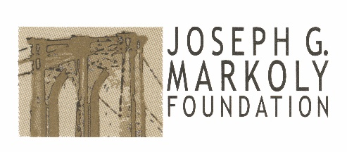
Funding Request Application - 2026
Instructions: Click the grey text box to enter your information. To change fields, either click to the desired field or use the ‘Tab’ button on your keyboard. Upon completion you may save this file and email it to us, or you may print and mail the completed form as noted in the instruction at the bottom of this application.
Organization Name: |  |  |  | Today’s Date:
Street Address:
Mailing Address:
(if different from street address)
Phone Number: |  |  | Fax Number:
Contact Name: |  |  | Contact Title:
Contact Email Address:
Current Board Chair:
(Must be other than contact person)
Tax Exempt Name:
(If different than above)
Federal Tax ID#
Briefly state your organization’s mission:
Funding Request Information
DESCRIPTION of request
and amount being requested:
 |  | $
Program Budget related to this request: |  | $
Program Director:

Funding Request Application – Page 2
List any funding commitments to requested project to date:
What percentage of the agency’s budget is spent on fundraising activities? | %
Does your organization submit an IRS form 990? | NO YES
Does your organization provide services regardless of race, color, gender, gender orientation, religion, age, disability or military status? | NO YES
Does your organization attempt to influence legislation and/or the candidacy of persons for elected office? | NO YES | Explain:
List your organizations top four funders: | 1
List your organizations top four funders: | 2
List your organizations top four funders: | 3
List your organizations top four funders: | 4
Funding requests must arrive at the foundation no later than June 1st of each year.  The Proposal and attachments should be sent electronically to squill773w@gmail.com  *PLEASE ALSO MAIL  A HARD COPY of the full Proposal to:  The Joseph G. Markoly Foundation, Inc.  Nancy Squillacioti, Trustee  1917 Aquarius Court  Oviedo, FL 32766 | Proposal Packet must contain:  - This completed Joseph G. Markoly Foundation Funding Request Application along with a cover letter of additional attachments describing the program of project, how it fills a need in the community, and what amount of funding you are requesting.  - A budget specifically indicating how the funding would be used.  - The most recent organizational budget as approved by your Board of Directors.  - A copy of your organization’s IRS Tax Exempt Certificate.  - Page one of the most recent 990 for the local agency applying for this grant. If your organization is part of a national organization, the foundation does not need a 990 for the national office.

